**Ques 1**: SDLC Overview - Create a one-page infographic that outlines the SDLC phases (Requirements, Design, Implementation, Testing, Deployment), highlighting the importance of each phase and how they interconnect.

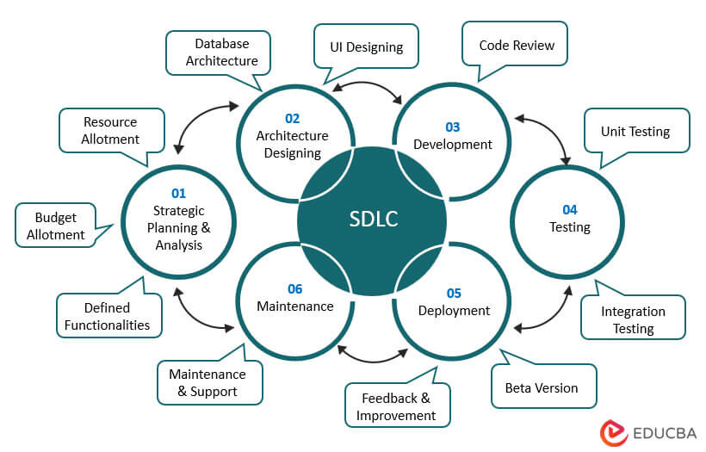

**1. Requirements Phase**

**Importance:**

* **Foundation of the Project:** Clear understanding of what the stakeholders need.
* **Scope Definition:** Determines project scope, goals, and deliverables.
* **Avoids Miscommunication:** Detailed documentation minimizes misunderstandings.

**2. Design Phase**

**Importance:**

* **Blueprint Creation:** Translates requirements into a detailed architecture.
* **Feasibility Analysis:** Ensures the design meets requirements within constraints.
* **Guides Development:** Provides a roadmap for developers.

**3. Implementation Phase**

**Importance:**

* **Coding the Solution:** Actual development based on design specifications.
* **Turning Ideas into Reality:** Converts plans into a working system.
* **Iterative Development:** Often involves coding, unit testing, and integration.

**4. Testing Phase**

**Importance:**

* **Quality Assurance:** Ensures the software meets requirements and is bug-free.
* **Verification and Validation:** Confirms that the software works as intended.
* **User Satisfaction:** Increases confidence in the product's reliability.

**5. Deployment Phase**

**Importance:**

* **Releases Software:** Delivers the final product to users.
* **User Training:** Ensures users understand how to use the software.
* **Feedback Collection:** Gathers user feedback for future improvements.